**BASIC NETWORK CONFIGURATION IN** **RHEL7.x , CENTOS 7.x**

This is document tells about how to setup static IP address , setting hostname etc…in Linux environment….

**Steps as follows…**

**Basic requirements:**

1. OS installed Centos7 and above versions /rhel7 and above versions.

Let’s start…

**Step1:**

Open terminal and enter the following command.

C:\Users\guru\Desktop\doc\Capture11.PNG

Here u will see all the network devices and there status and configurations such as ipaddress, device name, net mask etc.

**Step2:**

Change the directory to “**network-scripts”** by entering the following command.

C:\Users\guru\Desktop\doc\Capture2.PNG

Enter “**ls**” command to view the devices and there status.

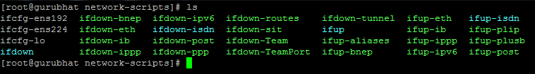

**Step3:**

Edit the device configuration using any of the text editors, here I am using **Vi Editor,** enter the following command to edit

C:\Users\guru\Desktop\doc\Capture4.PNG

Now you will see like below …..and edit the configuration as below by pressing “**I”**

Set “**Bootproto** to static and **Ipaddress** to any ipaddress you want to give here I am taking as below set net mask depending upon your **ip** range and set gateway and **DNS** . I believe that you know the basic terminologies as mentioned above if not I am sorry…in my coming tutorial I am going to tell you how to find those things if your using window and virtual box “vms”….

If you know them you can further move..

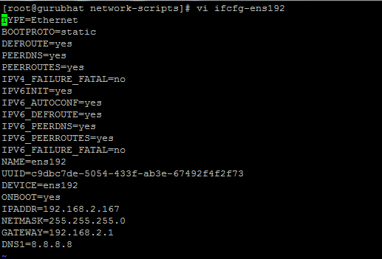

Save and Exit the editor by entering “**Escape**” and as Below..

C:\Users\guru\Desktop\doc\Capture6.PNG

Now your network device is set to the configuration you configured just now..

**Step4:**

Well …now you need to restart the network you can do that by entering following command.

C:\Users\guru\Desktop\doc\Capture7.PNG

Lets check …

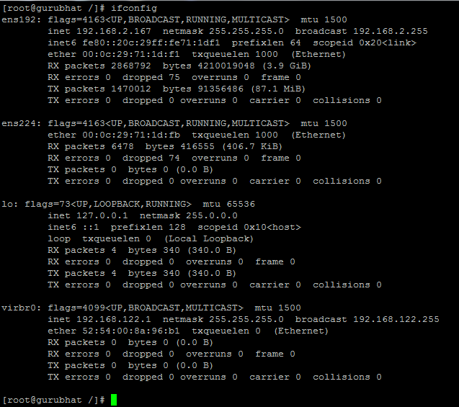

Now we have successfully set static ipaddress to our machine..

Now lets set hostname to our machine as follows..

**Step5:**

Check the current hostname by entering the following command.

C:\Users\guru\Desktop\doc\Capture8.PNG

change hostname by using following command.

C:\Users\guru\Desktop\doc\Capture9.PNG

Check the hostname by entering hostname command.

C:\Users\guru\Desktop\doc\Capture10.PNG

>>>>>>>>>>>>>>>>>>>>>>>>>>>>>>>>>>Thank you<<<<<<<<<<<<<<<<<<<<<<<<<<<<<<<<<<<